For Release: | immediately
Image: | 3 x jpeg
 |  | September 12, 2018
World's first standard end mill program for Hybrid Additive Manufacturing
FRANKEN introduces the world's first standard end mill program for hybrid additive manufacturing, which enables milling operations during the building process of additive construction of a component geometry.
“Hybrid additive manufacturing" is a process in which selective laser melting in the powder bed is combined with subtractive 3-axis high-speed milling in a single machine. On the one hand, this achieves significantly higher accuracies and surface qualities than are possible with conventional laser melting in the powder bed. On the other hand, zero point definition through machine-integrated spindle coordinate systems makes it possible to generate high-precision reference and clamping surfaces for the downstream process chain. This results in a minimization of the downstream process chain, especially for tool and mould making, rapid prototyping or small series production, as well as completely new possibilities in terms of design, structures or material properties.
The FRANKEN end mill tool range "Hybrid Additive Manufacturing" was specially developed for this type of manufacturing process. It comprises ball-nose end mills and radius end mills from the FRANKEN Expert program with a special neck design, cutting edge contour and coating, which are designed to meet the requirements of hybrid additive manufacturing. The pre-milling end mill with ball-nose geometry targets roughing and pre-finishing operations in order to produce a specific machining allowance on the additively manufactured component. The machining direction here is from top (Z+) to bottom (Z-). For finishing operations in construction layers no longer subject to thermal stress, the finishing cutter, also with ball-nose geometry, is recommended. The cutting area of the tool has been specially designed so that pull machining from bottom (Z-) to top (Z+) is possible in order to finish the material layers that are no longer thermally stressed.
The "back taper" radius end mill is intended for 2D machining of undercuts on the component. Its specifications are aimed at pre-finishing and finishing applications on additively produced components.
The ball end mills are available in cutting diameters from 0.6 to 3 mm, the radius end mills from 3.5 to 5 mm. All variants can be used for dry machining. Since an inert gas atmosphere and higher temperatures prevail in the machine chamber, dry machining is also absolutely necessary.
In addition to the Expert end mill program, the carbide end mills of the FRANKEN Micro product line and the "Enorm" end mill of the FRANKEN Top-Cut tool line are recommended for machining additively manufactured components.

About EMUGE-FRANKEN:
For nearly 100 years, the German company group EMUGE-FRANKEN has been one of the world`s leading manufacturers of precision tools for thread cutting, gauging, clamping and milling. With 1,800 employees, EMUGE-FRANKEN offers an innovative product program with 40,000 in-stock items and a multiple of that with customer-specific tools. The product range is focused on applications in the automotive industry, power plants, aerospace industry, medical technology as well as mechanical and plant engineering. As a system supplier for machining industry, EMUGE-FRANKEN has own branch offices or sales partners in 52 countries.

Press Contact:
Joerg Teichgraeber / Marketing Management
Joerg.Teichgraeber@emuge.de
Telephone +49 9123-186-555

EMUGE-Werk Richard Glimpel GmbH & Co. KG
Fabrik für Präzisionswerkzeuge
Nürnberger Straße 96-100, 91207 Lauf, Germany
Telephone +49 9123-186-0
www.emuge-franken.com

Images:

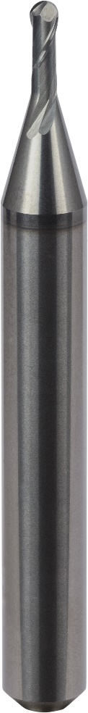
Image 1: The premilling tool version of the ball-nose end mill, the FRANKEN 2508L.

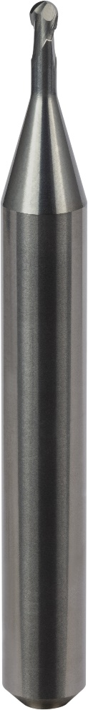
Image 2: The ball-nose end mill 2509L for finishing applications on additively manufactured components.

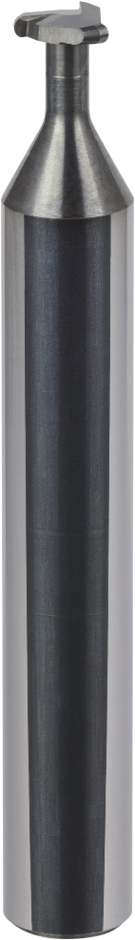
Image 3: The radius end mill 3060L is particularly designed for the machining of 2D-undercuts.

